Rebuilding ancient pathways: Model metalloenzymes for energy conversion

Hannah Shafaat, Assistant Professor
Department of Chemistry and Biochemistry
Ohio State University

Abstract:
Nature has evolved diverse systems to carry out energy conversion reactions. Metalloenzymes such as hydrogenase, carbon monoxide dehydrogenase, acetyl coenzyme A synthase, and methyl coenzyme M reductase use earth-abundant transition metals such as nickel and iron to reversibly generate and oxidize small-molecule fuels such as hydrogen, carbon monoxide, acetate, and methane. These processes are implicated in chemoautotrophic origins of life and play a key role in the metabolisms of ancient bacteria and archaea. However, while these enzymes are highly functional within their native environment, most are costly to isolate, sensitive to external conditions, and generally poorly suited for large-scale application. Additionally, the multimetallic active sites and auxiliary cofactors obscure distinguishing spectroscopic features and render detailed analyses challenging. As a result, the molecular mechanisms of catalysis remain relatively poorly understood, thwarting efforts to build biomimetic synthetic systems that act with the efficacy of native enzymes.

We have approached this problem from a metalloprotein engineering perspective. Azurin and rubredoxin are two of the most well studied proteins within the bioinorganic community. Both are robust platforms, known for their unique spectroscopic features and representative coordination geometries. By introducing non-native metals and redesigning the primary and secondary coordination spheres, we have been able to install novel activity into these simple electron transfer proteins, including catalytic hydrogen evolution, carbon dioxide fixation, and carbon monoxide activation. Optical, vibrational, and magnetic resonance spectroscopic techniques have been used in conjunction with density functional theory calculations to probe the active-site structures across different states in order to determine the catalytic mechanisms. These findings will be discussed in the context of identifying the fundamental principles underlying highly active native enzymes and applying those principles towards engineering effective model metalloproteins for energy conversion reactions.
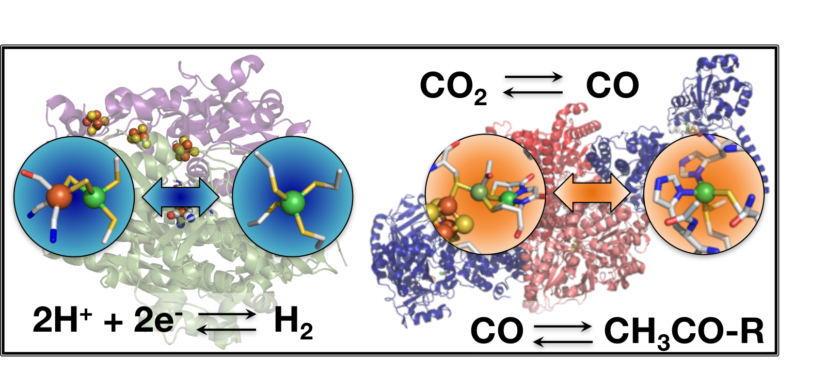

Bio:
Hannah received her B.S. in Chemistry from the California Institute of Technology (Caltech) in 2006, where she performed research on spectroscopic endospore viability assays with Adrian Ponce (NASA Jet Propulsion Laboratory) and Harry Gray. She received her Ph.D. in Physical Chemistry from the University of California, San Diego (UCSD) in 2011, under the direction of Professor Judy Kim, as an NSF Graduate Research Fellow and a National Defense Science and Engineering Graduate Fellow. During her graduate research, she used many different types of spectroscopy to study the structure and dynamics of amino acid radical intermediates in biological electron transfer reactions. After earning her Ph.D., Hannah moved across the ocean to Germany to study hydrogenase and oxidase enzymes and learn advanced EPR techniques as a Humboldt Foundation Postdoctoral Fellow working under Director Wolfgang Lubitz at the Max Planck Institute for Chemical Energy Conversion. Since starting her independent career, Hannah has received the NSF CAREER award in 2015 to support work on hydrogenase mimics, and in 2017, she was awarded the DOE Early Career award to support the group’s research on one-carbon activation in model nickel metalloenzymes.

