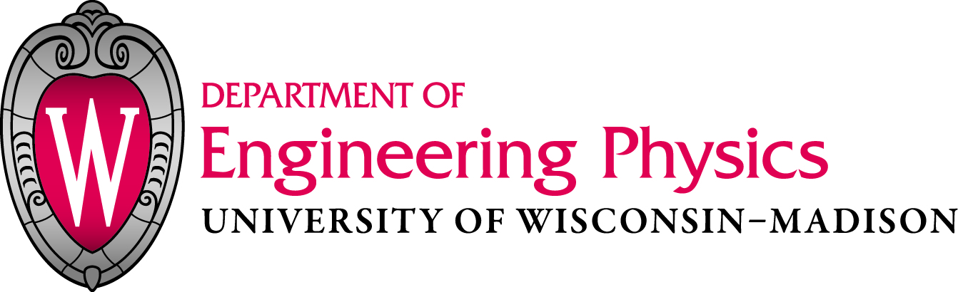
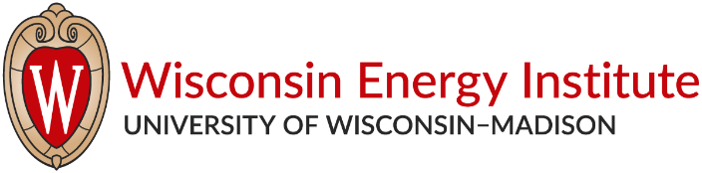

Presents:
Amber Robson
Clean Energy Policy Advisor, Third Way

The Role of Nuclear Energy in Deep Decarbonization
Abstract: Avoiding the worst impacts of climate change will require achieving deep decarbonization of global economies by 2050 or shortly after. Reaching the needed reductions in greenhouse gas emissions is going to require major transformations economy-wide which will ultimately increase the demand for low-carbon electricity. Several studies to date identifying potential pathways to deep decarbonization indicate that nuclear energy and carbon capture and storage will be critical technologies.

Third Way, a D.C. based think tank, is currently working to further highlight the importance that nuclear energy and carbon capture and storage will play in achieving climate mitigation goals. The first part of the effort is to identify solutions to preserve the existing nuclear fleet, which currently provides over 60% of low-carbon electricity in the U.S., overcome threats to early retirement. The next part is to help establish policies that will help advanced nuclear technologies move forward in the innovation cycle so that they may be commercialized and deployed in time to make a difference. A big part of the work is establishing messaging and identifying novel applications for nuclear energy in the context of a future low-carbon energy system.

Biography: Amber is a policy researcher and analyst with many years of experience working on Canada’s federal policy on greenhouse gases, air pollutants and air toxics. Since 2002 she has contributed technical expertise and coordinated multi-disciplinary teams on the development of multiple federal instruments. She has extensive knowledge of North American and International climate policy, greenhouse gas quantification, and renewables development. Amber has a background in Chemical Engineering and recently completed a Masters of Science in Energy Policy and Climate from Johns Hopkins University in Washington, D.C. Amber Robson is currently the Clean Energy Policy Advisor at Third Way, where she brings her technical and policy expertise to inform the organization’s work on nuclear energy and carbon capture and storage technologies.

Tuesday, 2/14/2017
4:00 PM
ERB 106

